DAY 10: EVENING ASSESSMENT  
  
1. Create a NumPy array of integers from 10 to 50 (inclusive).

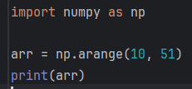

Output:

[10 11 12 13 14 15 16 17 18 19 20 21 22 23 24 25 26 27 28 29 30 31 32 33

34 35 36 37 38 39 40 41 42 43 44 45 46 47 48 49 50]

2. Create a 3x3 NumPy array of all True values.

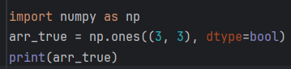

Output:  
[[ True True True]

[ True True True]

[ True True True]]

3. Create a 5x5 identity matrix.

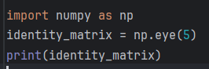

Output:  
[[1. 0. 0. 0. 0.]

[0. 1. 0. 0. 0.]

[0. 0. 1. 0. 0.]

[0. 0. 0. 1. 0.]

[0. 0. 0. 0. 1.]]

4. Generate an array of 10 random float numbers between 0 and 1.

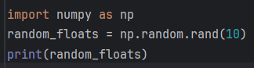

Output:  
[0.15678032 0.01609682 0.03895373 0.39374424 0.55734786 0.25640776

0.41258344 0.90689293 0.85216942 0.22811071]

5. Create a 1D array of 15 numbers equally spaced between 0 and 5.

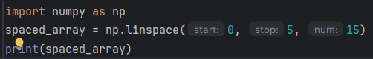

Output:

[0. 0.35714286 0.71428571 1.07142857 1.42857143 1.78571429

2.14285714 2.5 2.85714286 3.21428571 3.57142857 3.92857143

4.28571429 4.64285714 5. ]

6. Reshape an array of 12 elements into a 3x4 matrix.

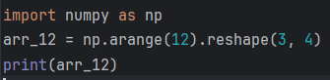

Output:

[[ 0 1 2 3]

[ 4 5 6 7]

[ 8 9 10 11]]

7. Replace all even numbers in the array [1, 2, 3, 4, 5, 6] with -1.

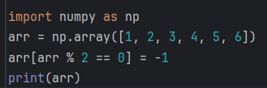

Output:  
[ 1 -1 3 -1 5 -1]

8. Extract all odd numbers from a 1D array ranging from 0 to 20.

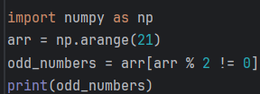

Output :

[ 1 3 5 7 9 11 13 15 17 19]

9. Create a 2D array of shape (4, 5) and calculate the sum of each column. .

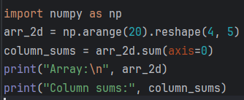

Outptut:

[[ 0 1 2 3 4]

[ 5 6 7 8 9]

[10 11 12 13 14]

[15 16 17 18 19]]

Column sums: [30 34 38 42 46]

10. Create two 3x3 arrays and perform element-wise multiplication

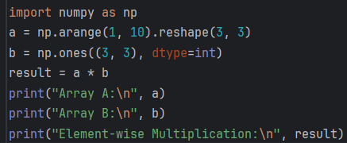

Output:

Array A:

[[1 2 3]

[4 5 6]

[7 8 9]]

Array B:

[[1 1 1]

[1 1 1]

[1 1 1]]

Element-wise Multiplication:

[[1 2 3]

[4 5 6]

[7 8 9]]

11. Create an array from 1 to 100 and count how many numbers are divisible by both 3 and 5.

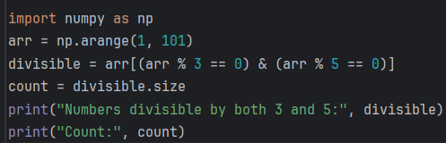

Output :

Numbers divisible by both 3 and 5: [15 30 45 60 75 90]

Count: 6

12. Normalize a NumPy array: subtract its mean and divide by its standard deviation.

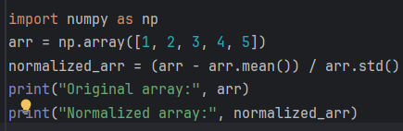

Output:  
Original array: [1 2 3 4 5]

Normalized array: [-1.41421356 -0.70710678 0. 0.70710678 1.41421356]